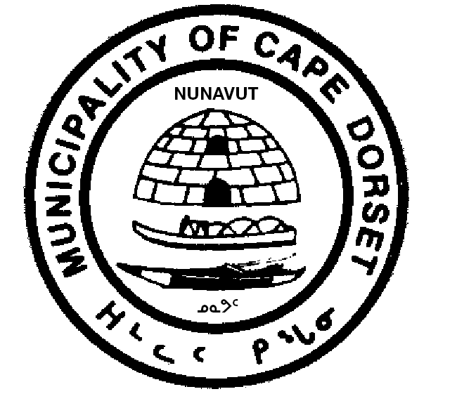
HAMLET OF CAPE DORSET

BYLAW NUMBER 148

SCHEDULE A

APPLICATION FOR BUSINESS LICENSE

a. Name of Applicant:
b. Name of Business:
c. Business Address:
d. Mailing Address:

e. Location of Business: Lot:________ Block ________ Plan ________
f. Telephone Number of Business:
g. Type of Business: _________________________________________________
_________________________________________________
h. Is this a junior business as defined in section 2 of the bylaw?
Yes No
(If yes, please complete section i.)
i. I, , being the parent or guardian of the applicant, do hereby give my consent to the above named to operate the aforementioned business.

Signature of Parent/Guardian Date

j. Is this a non-resident business? Yes No
k. Is this a renewal? Yes No

I, , hereby make application for a license in accordance with the particulars as above and certify that the above-mentioned information is correct.

Signature of Applicant Date

For Office Use Only:

Fee: $ License Number
Approved Rejected
Reason for rejection:

Senior Administrative Officer Date

Date License Issued: For Licensing Period Ending:

Documentation Attached: WSCC Compliance Certificate Number

SCHEDULE B

FEES
Airlines, Airline Agencies | $ 50.00
Apartment Rental Agencies (per unit) | 100.00
Banks, Credit Unions, and Financial Services (per Branch) | 250.00
Billiard Halls (per table) | 50.00
Bulk Petroleum Products Dealer | 250.00
Businesses Not Specified | 250.00
Cable T.V. Companies | 100.00
Coin Operated Vending Machines (per machine) | 25.00
Electrical Power Plants Producing Power for Public Sale | 250.00
General and Building Contracting | 250.00
Hairdressing and Other Personal Grooming Business | 50.00
Hotels and Motels (per room) | 50.00
Non-resident Businesses and Professions | 500.00
Photographers | 50.00
Printers | 50.00
Repair and Service Shops | 100.00
Restaurant Keepers | 100.00
Taxi Service (per taxi) | 100.00
Telephone Companies | 250.00
Tourist Outfitting Services | 150.00
Vehicle and Equipment Rental | 50.00
Retail / Convenience Store | 100.00
Local Cartage | 50.00

